Innovation Plan
Jal Rekha



Document Title | Innovation Plan
Prepared By | Dheeraj Motiyani, Sr. Business Analyst
Project Name | Jal Rekha
Version | 1.0
Date of Preparation | 24-12-2025
Reviewed / Approved By

Table of Contents
1. Introduction 2
2. Purpose 3
3. SonarQube – Code Quality & Security 3
4. SBOM – Software Bill of Materials 3
5. Fortify & Secure VPN Access 4
6. DevSecOps Integration 4
7. Expected Benefits 4
8. Alignment with Organizational Objectives 4
9. Innovation Identification 6
11. Evaluation & Prioritization 7
12. Pilot Implementation Plan 8
13. Pilot Review & Analysis 9
13.1. Deployment Plan 10
13.2. Measurement & Tracking 10
13.3. Institutionalization & Closure 11
13.4. Risks and Mitigation 11
13.5. Continuous Monitoring 11

1. Introduction
The Jal Rekha project is a comprehensive digital water governance platform developed to support planning, monitoring, quality assurance, and reporting of water supply schemes across the state. The platform integrates multiple modules and stakeholders through secure web and mobile applications.

2. Purpose
To define the approach and plan for identifying, evaluating, piloting, and institutionalizing innovative improvements that enhance process performance and support organizational business objectives.
This innovation plan focuses on adopting modern DevSecOps practices such as automated code quality checks, software supply chain transparency, and application security testing to ensure Jal Rekha remains secure, scalable, and compliant with government IT standards.

3. SonarQube – Code Quality & Security
SonarQube is implemented in the Jal Rekha project to continuously analyze source code and detect bugs, vulnerabilities, code smells, and maintainability issues across backend services, web portals, and supporting APIs.
- Enforces coding standards
- Detects security vulnerabilities early
- Monitors technical debt
- Quality gates before deployment

4. SBOM – Software Bill of Materials

SBOM implementation provides a complete inventory of open-source and third-party components used within Jal Rekha applications. This improves transparency and enables proactive vulnerability management.
- Dependency visibility
- Faster security impact analysis
- Compliance with security audits
- Reduced supply-chain risks

5. Fortify & Secure VPN Access

Fortify Static Application Security Testing (SAST) is used to identify security weaknesses such as SQL injection, XSS, and insecure authentication. All development and testing activities are conducted over secure VPN access to protect sensitive project data.
- OWASP Top 10 coverage
- Secure remote access via VPN
- Controlled environment access
- Secure credential handling

6. DevSecOps Integration
By integrating SonarQube, SBOM, and Fortify into CI/CD pipelines, Jal Rekha follows a DevSecOps model where security and quality checks are automated and continuous throughout the development lifecycle.

7. Expected Benefits
- Higher software quality
- Reduced security vulnerabilities
- Faster and safer releases
- Improved compliance and audit readiness
- Increased confidence for government stakeholders

8. Alignment with Organizational Objectives

Business Goal | Related Process Area / Initiative | Expected Benefit
Reduce delivery time by 5% | Automated Code Review using SonarQube (CI-integrated static analysis, quality gates) | Early defect detection, reduced rework, faster approvals
Reduce delivery time by 10% | DevSecOps CI/CD Pipeline (Automated build, test, scan, deploy) | Faster and more reliable release cycles
Improve application security & compliance | Fortify SAST + Secure VPN Access | Early vulnerability detection, OWASP compliance, secure remote access
Improve software supply-chain transparency | SBOM Generation & Dependency Tracking | License compliance, reduced third-party risk
Increase system stability & performance | Technology Upgrade – .NET Framework 4.8 | Improved response time, better memory handling
Enhance citizen & field-user experience | Optimized APIs & Mobile/Web Performance Tuning | Faster data entry, reduced latency for FE & Contractor
Improve audit readiness & governance | Centralized Logs, Quality Reports, and Security Reports | Easy audit tracking, compliance with government standards
Enable cycle-wise controlled delivery | Cycle-based DevSecOps Adoption (Cycle 1/2/3) | Predictable releases, phased risk reduction

9. Innovation Identification

Objective:
Capture innovation ideas from multiple sources, evaluate their relevance, and assess their impact on delivery efficiency, quality, security, and user experience in the Jal Rekha project. Capture ideas from various sources and assess their potential impact.
Source of Idea | Description of Idea | Problem Addressed | Expected Impact
Retrospective / Lessons Learned (Cycle 1) | Introduce automated code quality and static analysis using SonarQube integrated with CI pipeline | High manual code review effort, late defect identification | Reduce code review effort by 30%, improve code quality and maintainability
Process Improvement Initiative (Cycle 2) | Implement DevSecOps CI/CD pipeline with automated build, test, scan, and deployment | Manual code merging, delayed deployments, higher release risk | Reduce delivery and deployment cycle time by 10%, faster and predictable releases
Security & Compliance Review (Cycle 3) | Integrate Fortify SAST and SBOM generation with secure VPN access for development and deployment | Security vulnerabilities identified late; lack of third-party dependency visibility | Early vulnerability detection, improved compliance, reduced security risks
Technology Modernization Strategy | Upgrade application framework from .NET 3.5 to .NET 4.8 | Legacy framework limitations, lower performance, outdated security features | Improved application performance, enhanced security, better scalability
User Feedback (Field Engineers & Contractors) | Optimize APIs and application response time through performance tuning and modern framework support | Slow response time affecting field and contractor productivity | Enhanced user experience, faster data submission, reduced field delays
Audit & Governance Requirements | Centralize quality, security, and deployment reports for audit readiness | Manual report preparation during audits | Improved traceability, faster audits, and compliance with government standards

11. Evaluation & Prioritization
Objective:
Evaluate identified innovation initiatives based on business impact, implementation feasibility, cost considerations, security compliance, and return on investment (ROI), and prioritize them for phased implementation across Jal Rekha project cycles. Evaluate ideas based on feasibility, impact, and ROI.
In. SNo | Innovation Initiative | Impact | Cost | Priority | Status | Remarks
1 | Upgrade application framework to .NET 4.8 | High | NA (In-house upgrade) | High | Completed | Improved application performance, enhanced security features, better scalability, and improved user experience
2 | Implement SonarQube automated code quality & static analysis | Medium–High | NA (Open-source / Enterprise licensed) | High | Completed | Reduced manual code review effort, early defect detection, improved maintainability and code quality
3 | Implement CI/CD pipeline (DevSecOps) for Jal Rekha | High | NA (Existing DevOps tools) | High | WIP | Automated build, test, security scan, and deployment; faster and more reliable releases
4 | Integrate Fortify SAST and SBOM generation | High | NA | High | Planned | Early vulnerability detection, third-party dependency visibility, compliance with security and audit standards
5 | Secure development & deployment using VPN-based access control | Medium | NA | Medium | Completed | Improved environment security, controlled access for developers and vendors
6 | Centralized quality, security, and deployment dashboards | Medium | NA | Medium | Planned | Improved monitoring, reporting, and audit readiness across project cycles

12. Pilot Implementation Plan
Objective:
Define and execute controlled pilot implementations to validate innovation initiatives, measure measurable benefits, mitigate risks, and ensure readiness for organization-wide rollout across Jal Rekha project cycles. Define pilot projects to validate innovation ideas before organization-wide rollout.
In. SNo | Pilot Project / Area | Duration | Pilot Owner | Key Metrics | Success Criteria
1 | Jal Rekha Application Upgrade to .NET 4.8 (Pilot in selected districts) | 8 Weeks | Development Team | Page response time, CPU & memory utilization, application error logs, API response time | ≥20% improvement in response time; stable performance; zero critical defects during pilot
2 | SonarQube Automated Code Review Enforcement (All Jal Rekha modules) | Continuous | Development Team | Code complexity, duplication %, test coverage %, bugs & vulnerabilities, Quality Gate pass rate | 100% builds passing quality gates; reduction in code smells; improved maintainability index
3 | CI/CD Pipeline (DevSecOps) Pilot | 10 Weeks | Development & DevOps Team | Deployment frequency, build success rate, test pass rate, lead time for changes, MTTR | Automated builds & deployments; reduced manual intervention; consistent, low-risk releases
4 | Fortify SAST & SBOM Integration | 6 Weeks | Security & DevOps Team | Vulnerabilities detected, critical/high issue resolution rate, SBOM generation success | 100% code scanned; all critical/high vulnerabilities resolved before deployment
5 | Secure VPN-based Access for Development & Deployment | 4 Weeks | IT Security Team | Unauthorized access attempts, VPN uptime, access audit logs | Controlled access to environments; zero security breaches; complete audit traceability

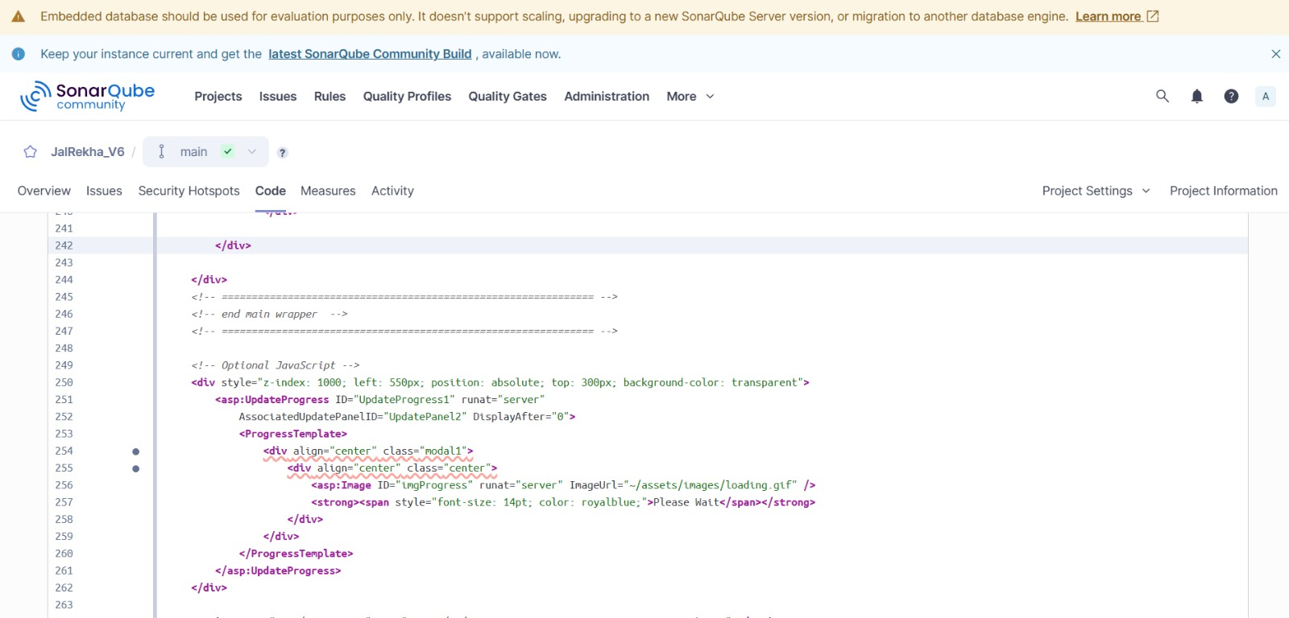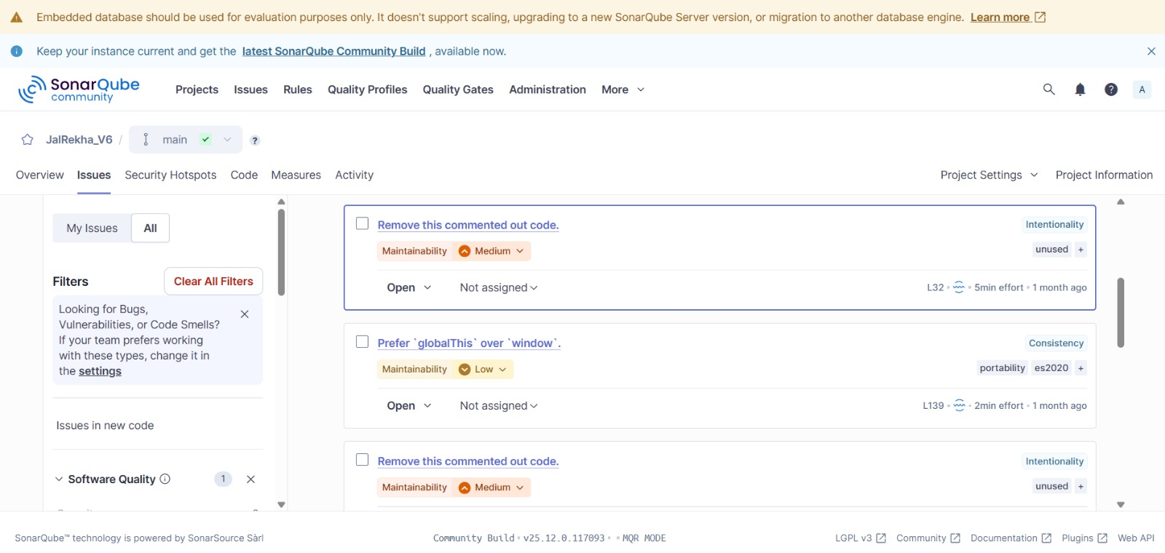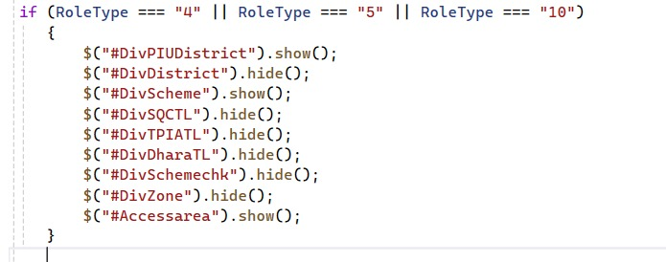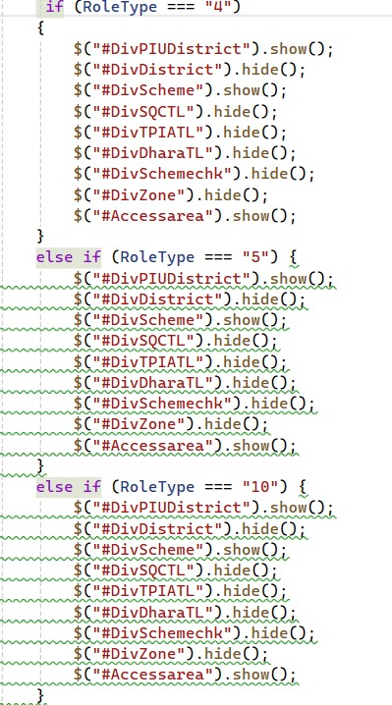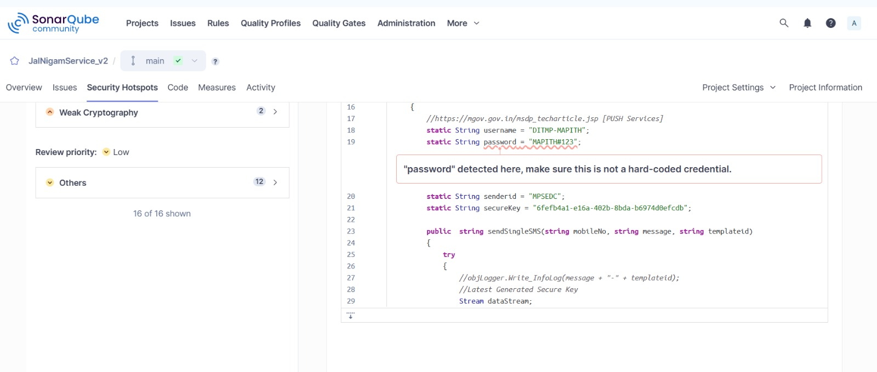

13. Pilot Review & Analysis
Upgrade to .NET 4.8:
- Pilot module showed approximately 20% improvement in performance.
- Reduced memory usage and improved compatibility.
- Required updating certain third-party libraries.

Automated Code Review using SonarQube:
- Identified vulnerabilities, code smells, and duplications.
- Reduced manual review effort by 20%.
- Required initial tuning of quality gates and developer training.

CI/CD Implementation:
- Deployment time reduced by approximately 40%.
- Build process became consistent and error-free.
- Required DevOps–Infra coordination and automation enhancements.

13.1. Deployment Plan
Rollout Strategy:
- Phase-wise deployment of .NET 4.8, SonarQube rules, and CI/CD pipeline.
- Prioritize critical modules first and maintain rollback versions.

Affected Teams:
- Development, QA, DevOps, Infrastructure, Security.
Training Needs:
- .NET 4.8 refresher, SonarQube issue resolution training, CI/CD pipeline usage.

13.2. Measurement & Tracking
Metrics for .NET 4.8:
- Response time, memory usage, CPU usage, exceptions.
Metrics for SonarQube:
- Code smells reduction, vulnerabilities trend, duplicate code %, Quality Gate results.
Metrics for CI/CD:
- Deployment frequency, build success rate, MTTR, change failure rate, deployment time.

13.3. Institutionalization & Closure
- Updated coding standards to adopt .NET 4.8.
- Added SonarQube quality gate policies.
- Updated CI/CD pipeline documentation and rollback procedures.
- Stored all process documents in project repository.
- Conducted team-wide communication and knowledge-sharing.

13.4. Risks and Mitigation
- Library incompatibility risk → mitigate by pre-migration analysis.
- Developer unfamiliarity with SonarQube → conduct training.
- CI/CD failures → test pipelines in sandbox before production rollout.
- Resistance to process change → awareness and gradual rollout.

13.5. Continuous Monitoring
- Quarterly monitoring of performance after .NET 4.8 upgrade.
- Weekly SonarQube scan reviews and monthly code quality reports.
- Continuous monitoring of CI/CD pipeline health and deployment efficiency.
- Capture new improvement ideas through retrospectives and user feedback.

